**CO326 - Industrial Networks**

**Lab 01 - Serial Port I/O**

**03/03/2023**

**E/18/077 – Dharmarathne N.S. , E/18/227 Mudalige D.H.**

# Part 1

1. Serial data (text) transfer between two virtual ports with two Tera Term terminals.

COM1 to COM2

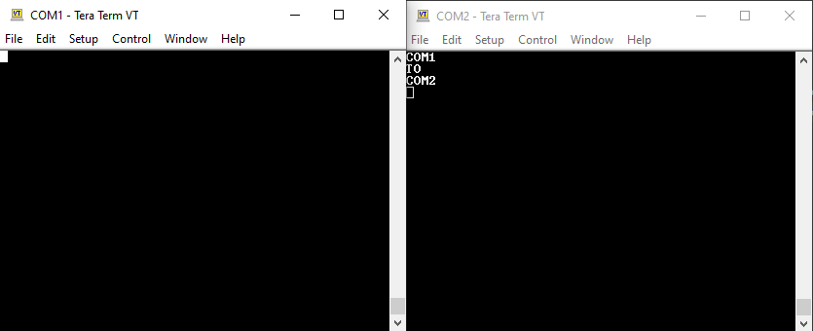

COM2 to COM1

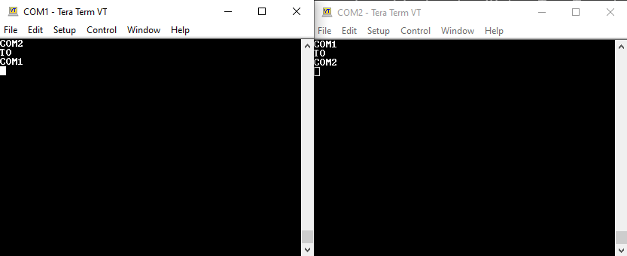

1. Output of the monitoring tool when the above data transferring occurs.

Raw Data View

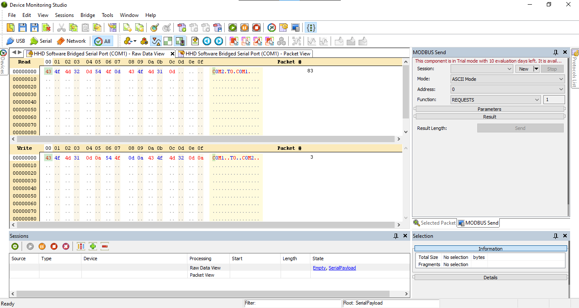

Packet View

# Part 2

I. The proteus setup

Before the simulation

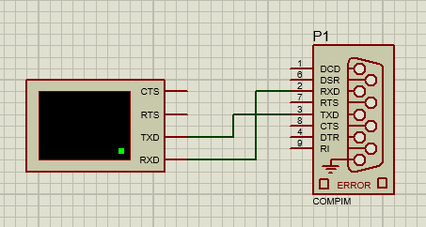

After the simulation

II. Serial data (text) transfer between two virtual ports performed with Tera Term terminal and virtual terminal in Proteus.

COM1 to COM2

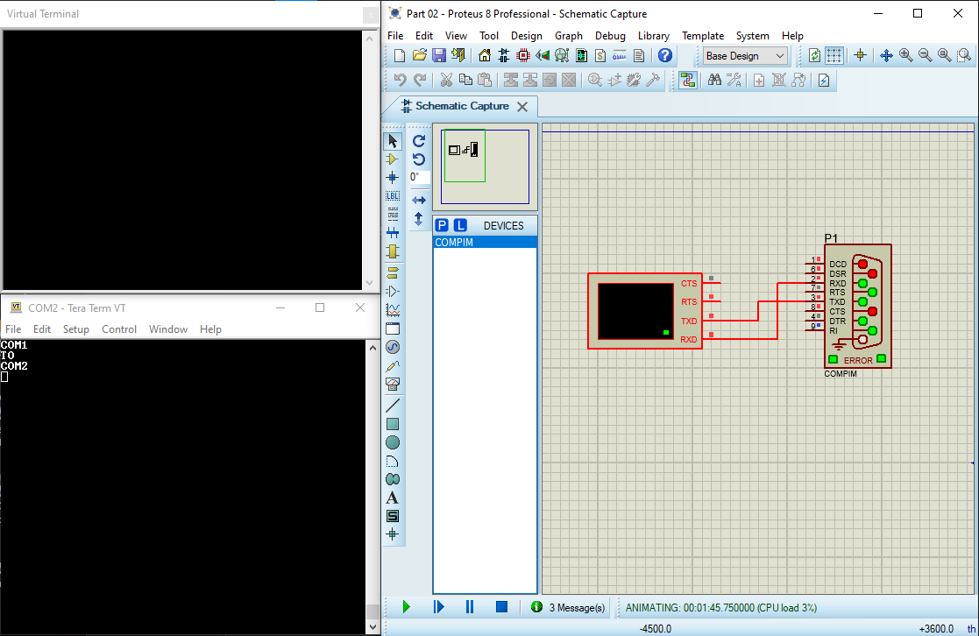

COM2 to COM1

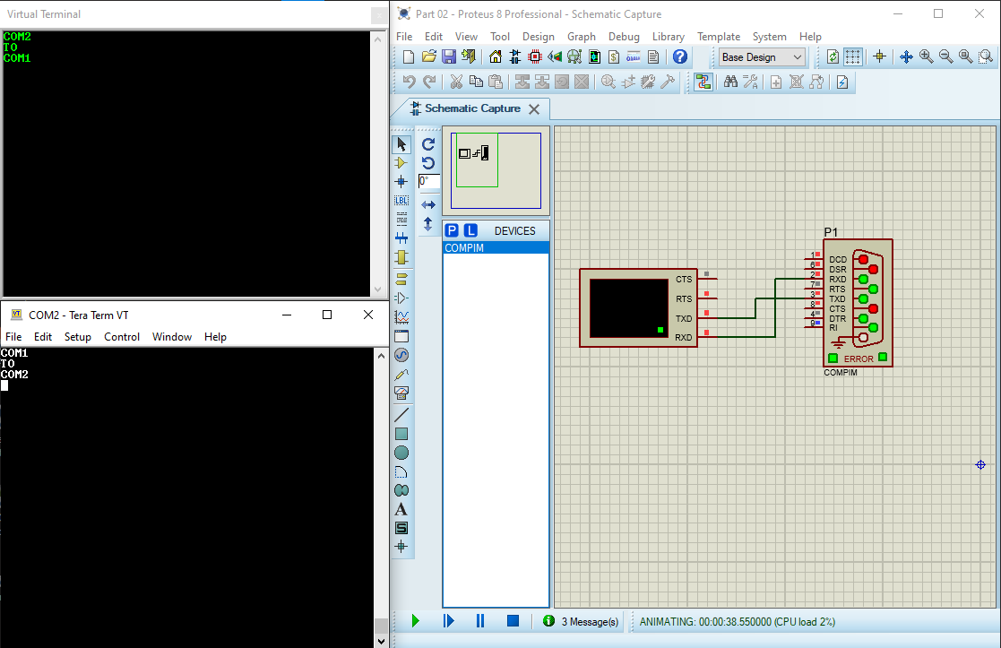

# Part 3

I. The proteus setup

Before the simulation

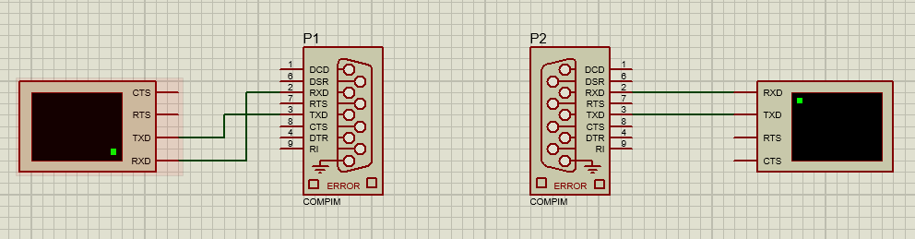

After the simulation

II. Serial data (text) transfer between two virtual ports performed with two virtual terminals in Proteus.

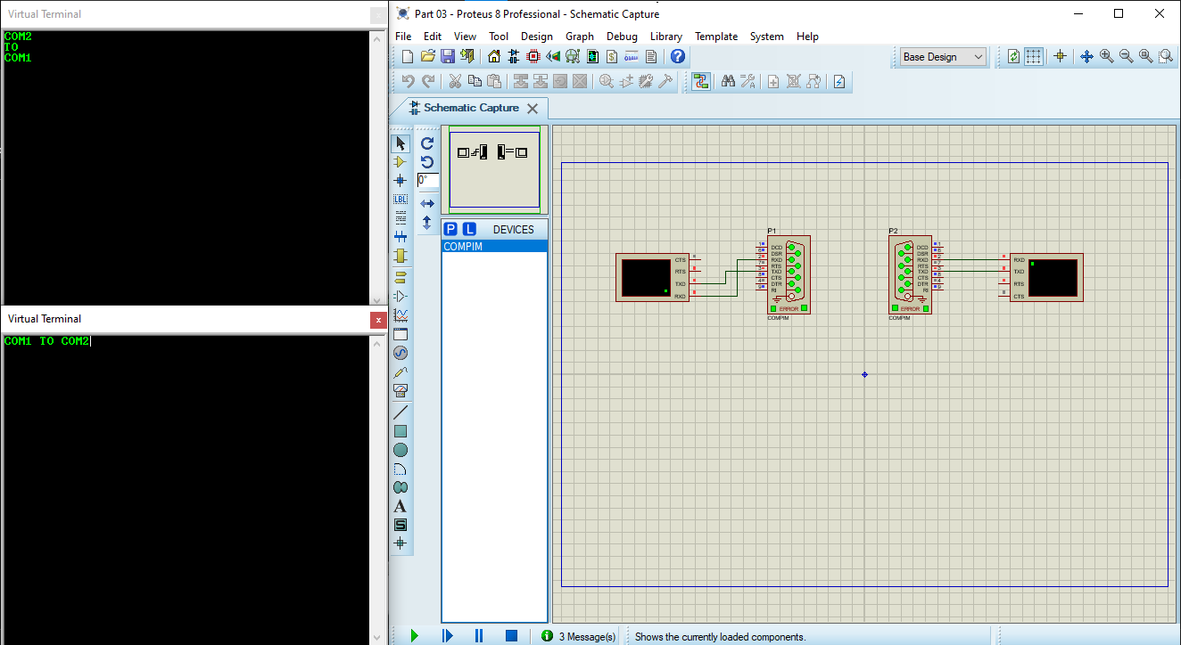

# Part 4

I. The proteus setup

II. The proteus setup all stages LEDs (lighting, not lighting)

1. Lighting Red LED

1. Lighting Yellow LED

1. Lighting Green LED

1. All LEDs are off

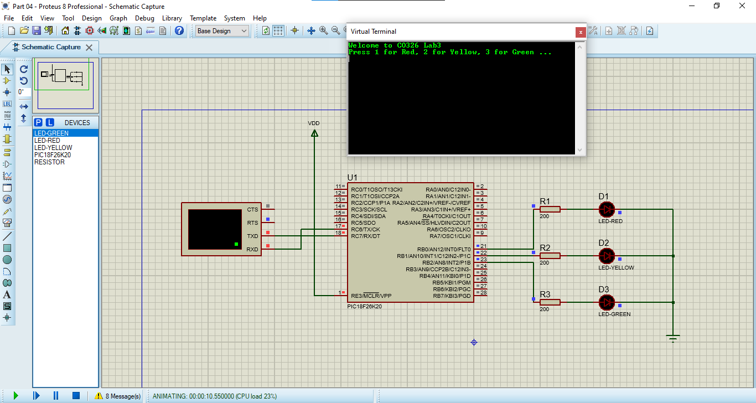

1. All LEDs are on

# Part 5

I. The proteus setup

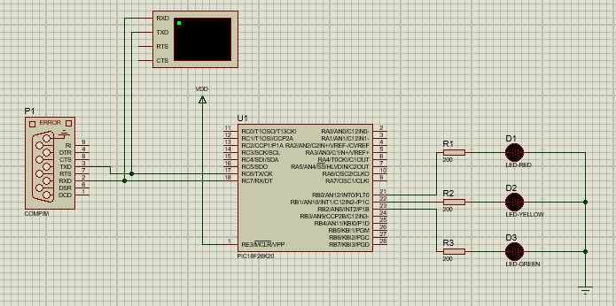

II. Serial data (text) transfer between two virtual ports performed with Tera Term terminal and virtual terminal in Proteus for all stages of LEDs.

1. Lighting Red LED

1. Lighting Yellow LED

1. Lighting Green LED

1. All LEDs are off

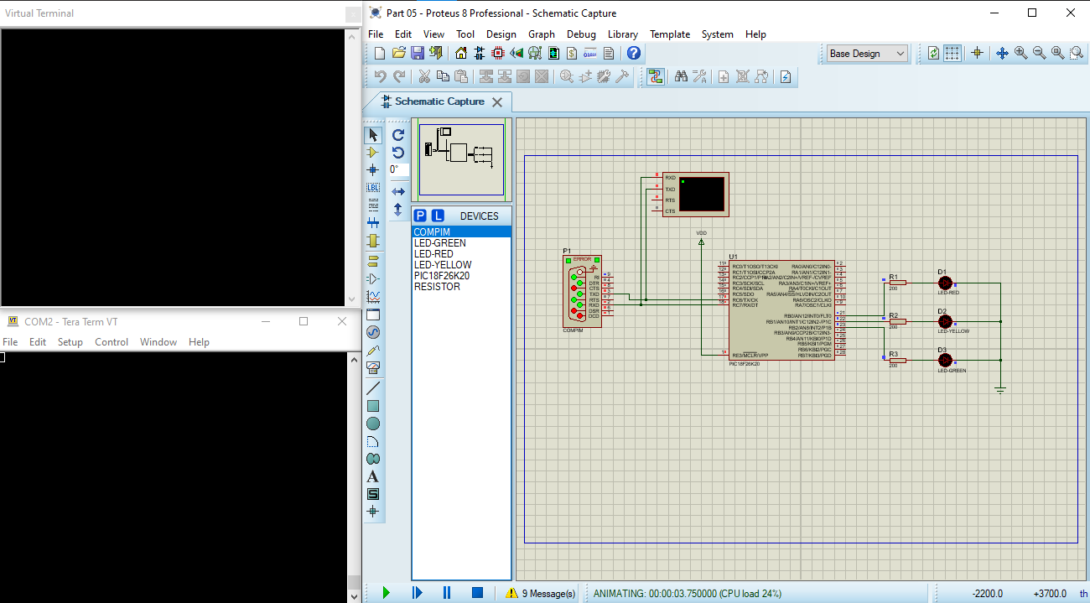

1. All LEDs are on

